CX1003 MINI-PROJECT REPORT

By Iskandar, Amadeus and Benjamin

**Table of Content**

1. Introduction
2. Description
3. Flow Chart
4. Algorithm Design

A. Store and display stall information

B. Store and display stall menus

C. Display stall information and menus based on the current system date and time

D. Display stall information and menus based on user-defined date and time

E. Calculate estimated waiting time for the stall by asking user to enter the number of people in the queue

F. Allow to check the operating hours for all stalls

1. Program Testing: Error Handling Test Cases
2. Reflections

**Introduction**

This report serves to illustrate our Real-time NTU North Spine Canteen

information system. We have designed a web application that fellow NTU students can utilize in order to access real-time information on the availability of food stalls as well as preorder and make online payments for their meals.

**Description**

To build this web application, we had to develop the frontend and backend. The frontend, is the display of information and the platform where users interact with the application. The backend, consists of the database, application, and server, which handles the backend logic.

In the development of the frontend, we used the following tools to create a user-friendly Graphical User Interface(GUI) for users to navigate through the website:

* HTML
* CSS with Bootstrap Framework
* JavaScript

For backend logic, we used Python. Apart from our self-defined functions, we have utilized the following external libraries:

* Flask: Python’s web development framework
* WTForms: A form validation library
* datetime module: To create datetime objects and obtain current date/time
* json module: To store data on the stalls and menu items in JSON

**Flowchart**

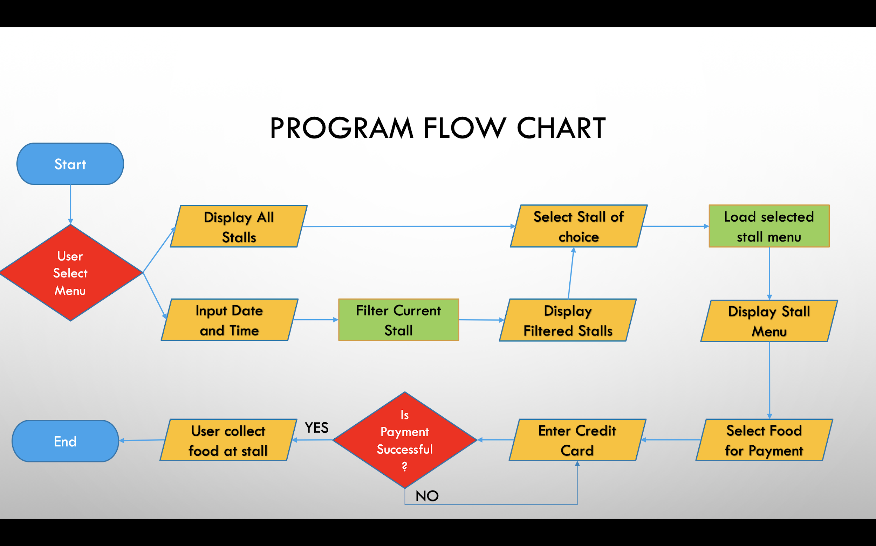

**Algorithm Design**

**A. Store and display stall information**

When a user enters the stall page, all the information of the stalls will be displayed.

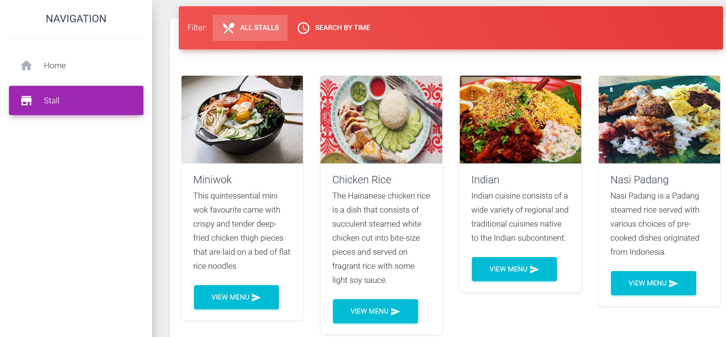

Stall information is stored in a json file, stall.json as a list of dictionaries.

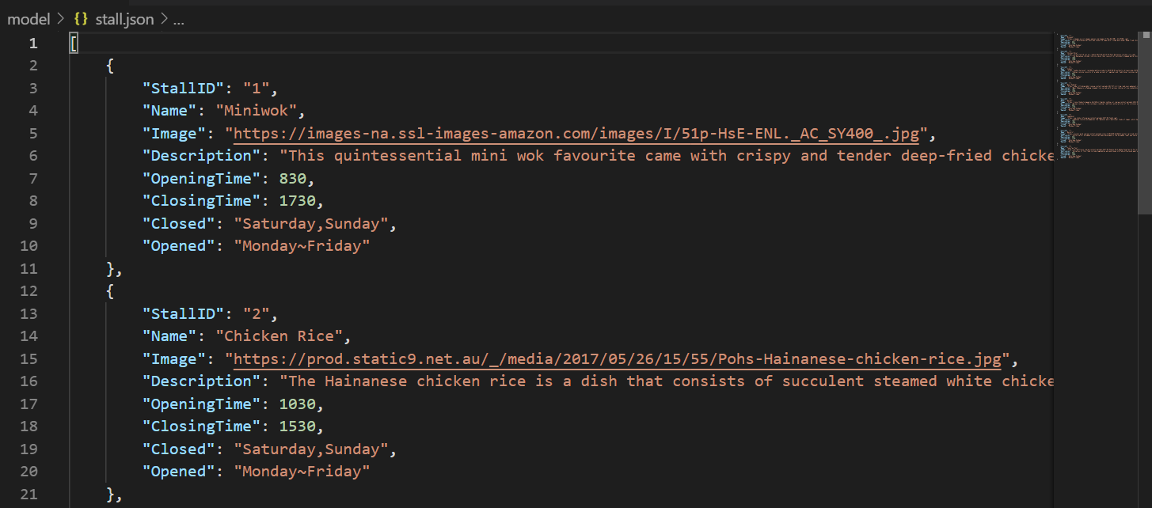

This information is accessed by stall.py to be imported to the main app.py file.

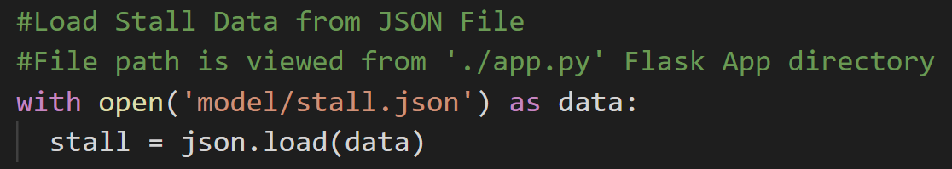

The function to return the stall list to app.py, GetAllStall, is called by Stall = GetAllStall().

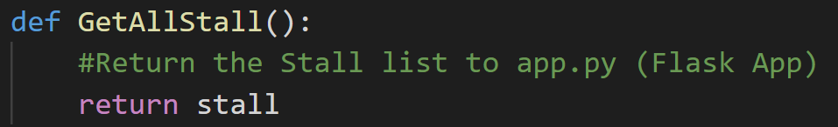

The information is then passed to the “/stall” html template using request.method ‘GET’, and displayed on the page.

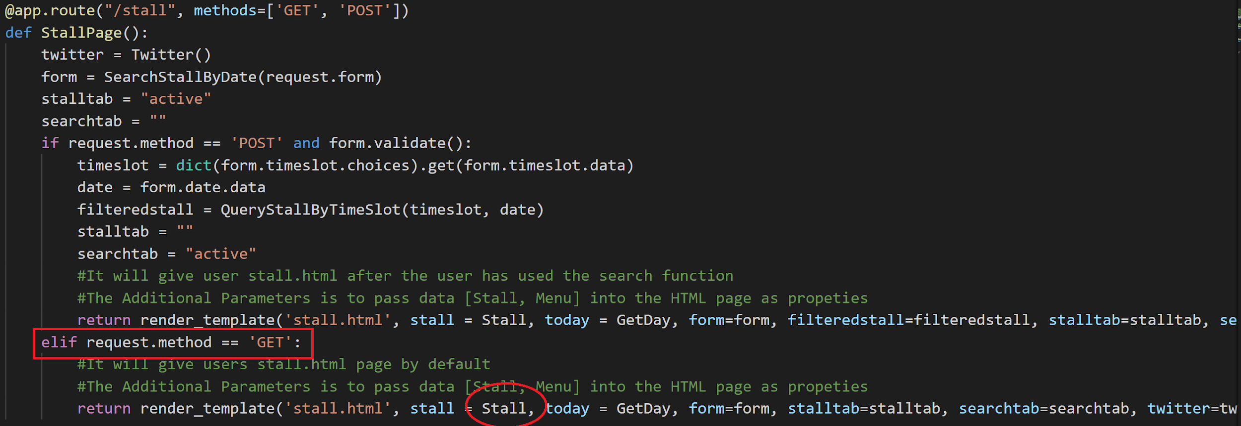

**B. Store and display stall menus**

Each stall on the “/stall” page has a “View Menu” button, which directs the user to the “/menu page” with that stall’s menu.

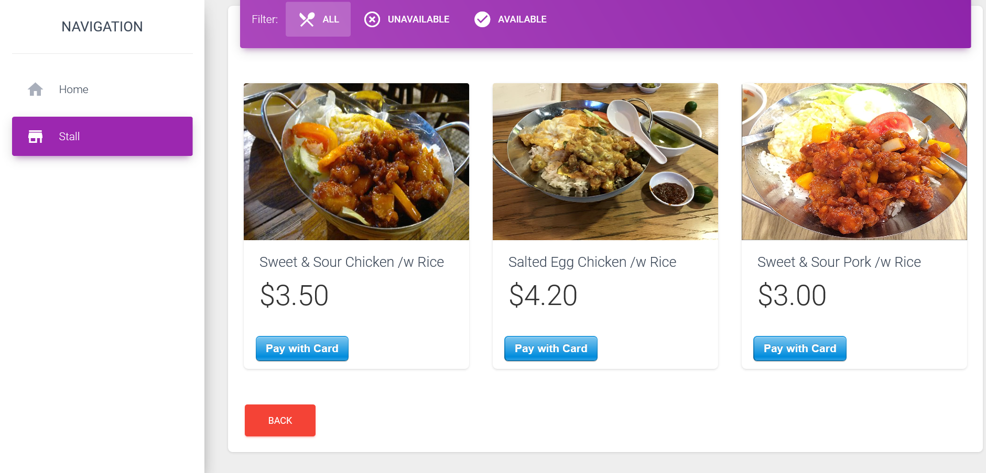

Menu information is stored in menu.json. Each dish has an associated StallID corresponding to its stall.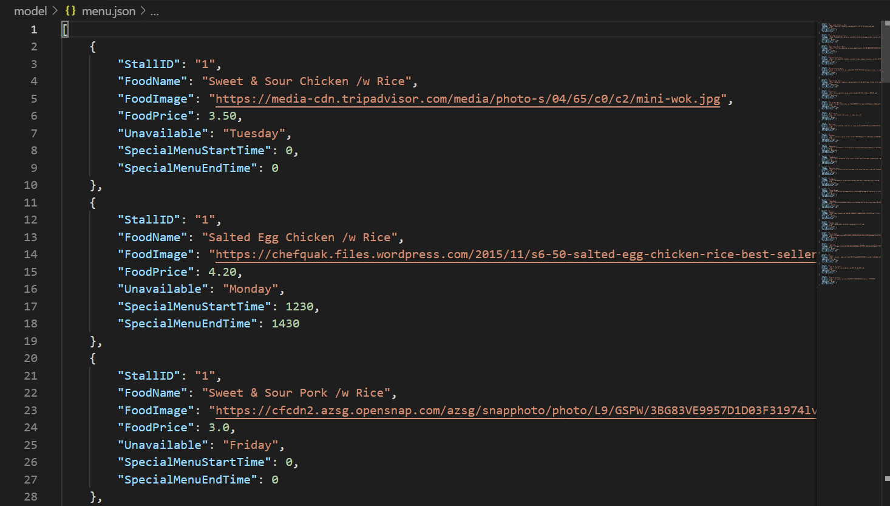

The information is then passed to menuitems.py. To ensure that only the menu items of the stall is displayed and not from other stalls, the function StallMenu() is used. StallMenu(stallid) filters menu items by adding only the items that have the same StallID as the argument.

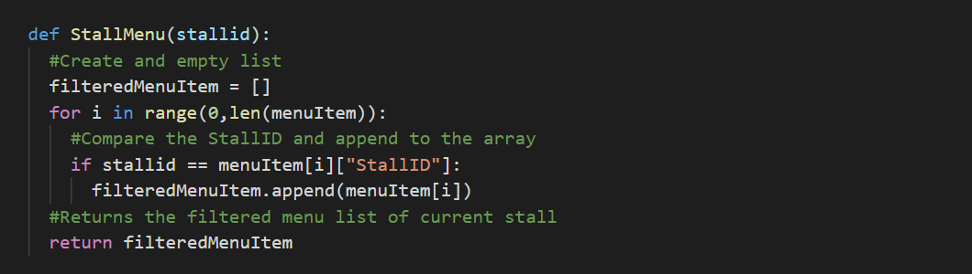

menuitems.py is then imported into app.py. The function is then invoked, MenuItems = StallMenu(id), to retrieve the menu information. The information is then rendered to the “/menu” html template.

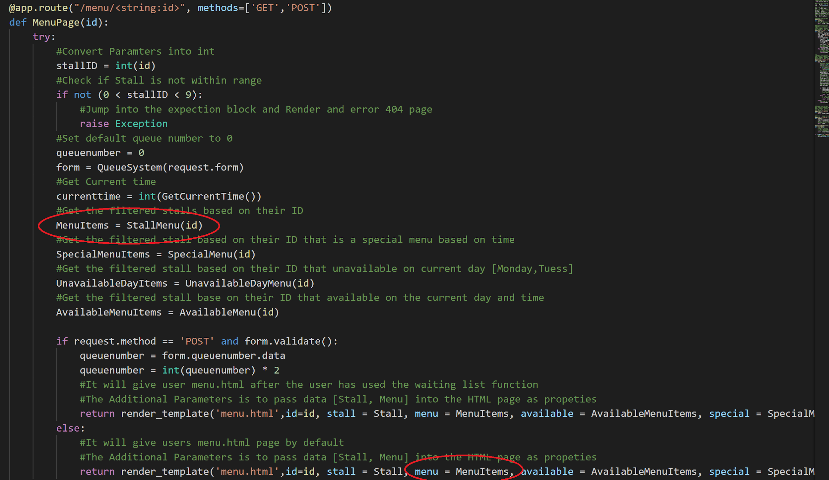

**C. Display stall information and menus based on the current system date and time**

Based on the current date and time, the user can view the menu of each stall to see the dishes available and unavailable at that time.

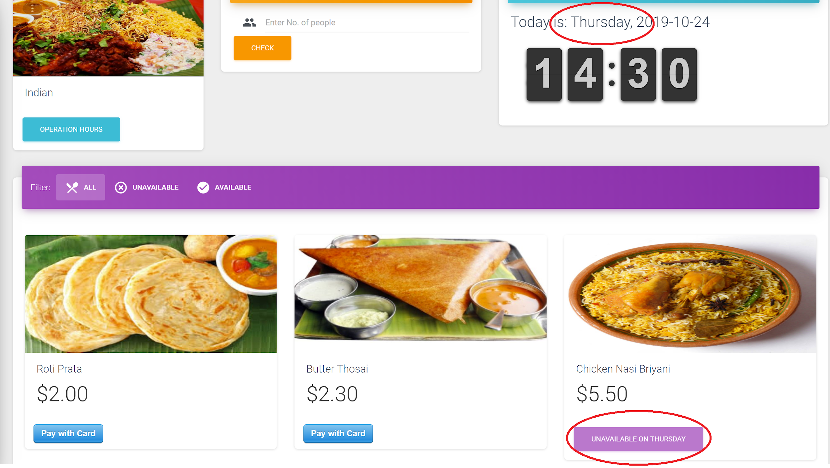

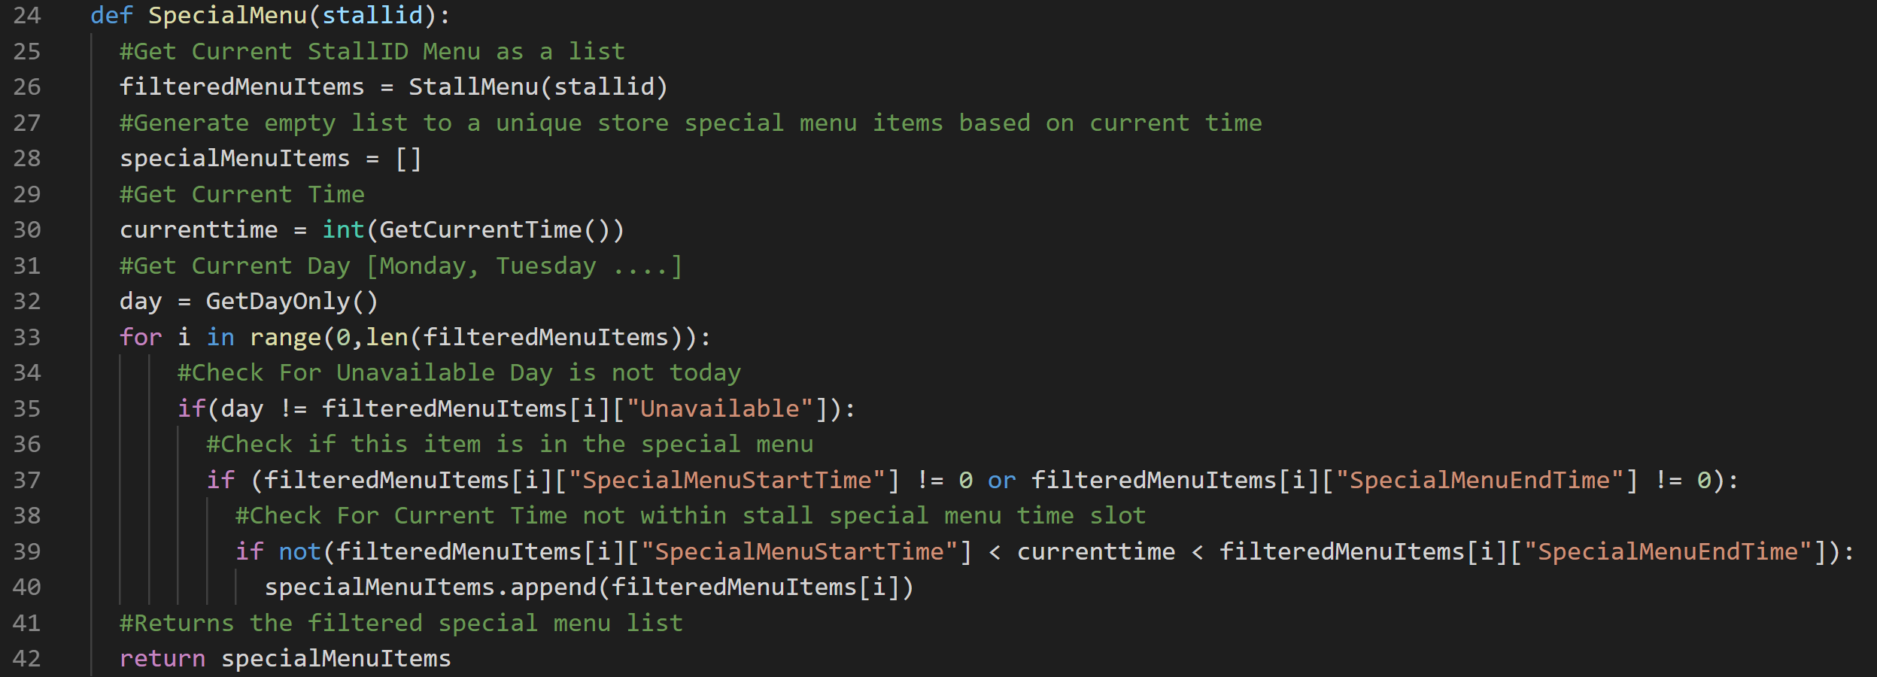

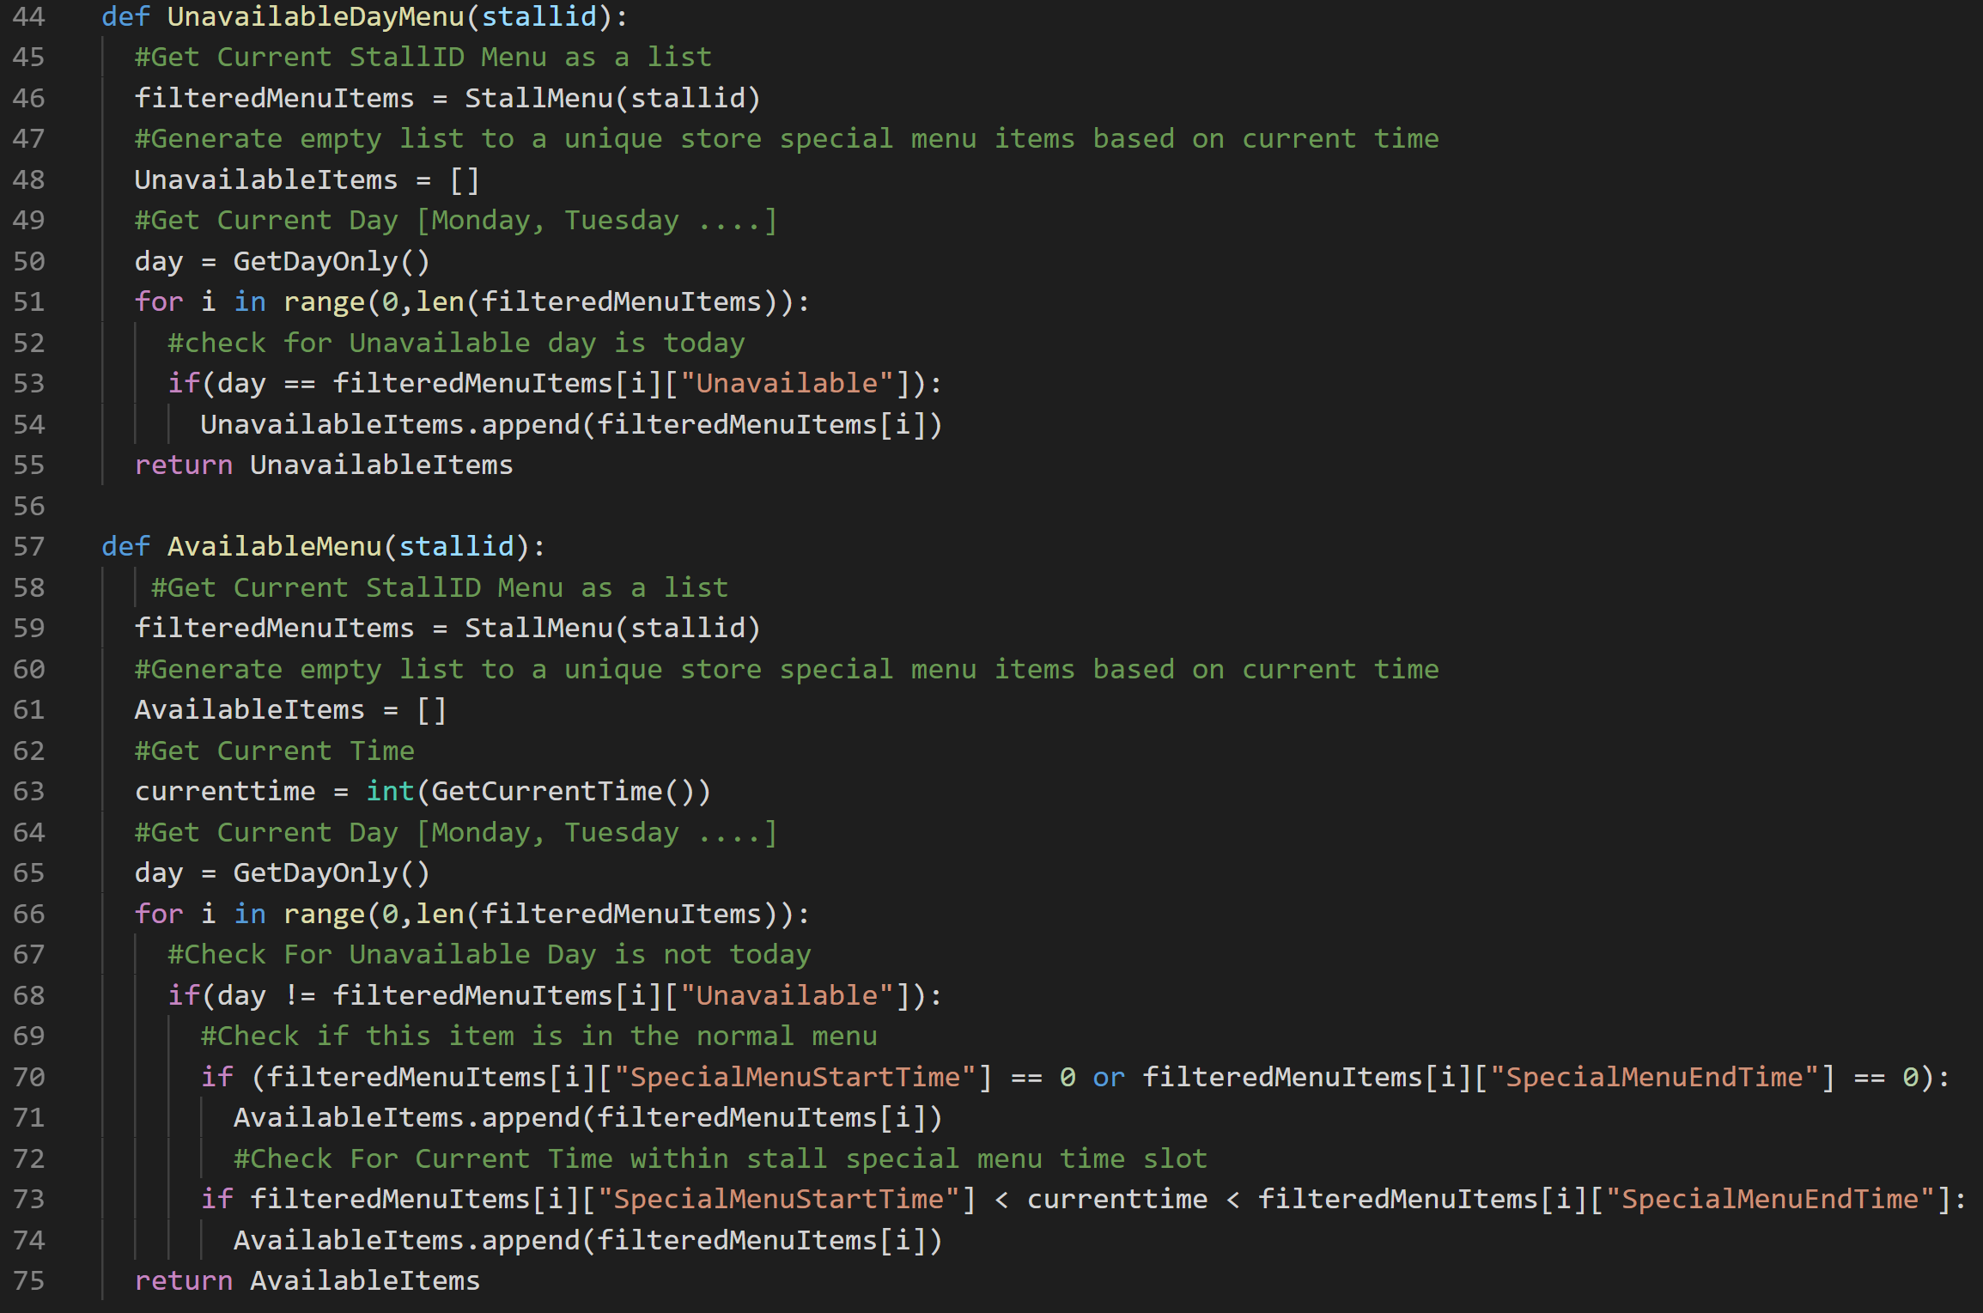

At the menu page of a particular stall, its menu will be rendered on the page. Based on the above 3 defined functions in menuitems.py, we are able to obtain the stall’s special menu as well as the menu that is available and unavailable based on the current time and date. The 3 arrays of special, unavailable and available menu items returned are then displayed on the browser.

**D. Display stall information and menus based on user-defined date and time**

In the Stall page, users can switch to the “Search By Time” tab to view a form. This form receives two inputs, date and time, and displays the stalls that are open during that user-specified period.

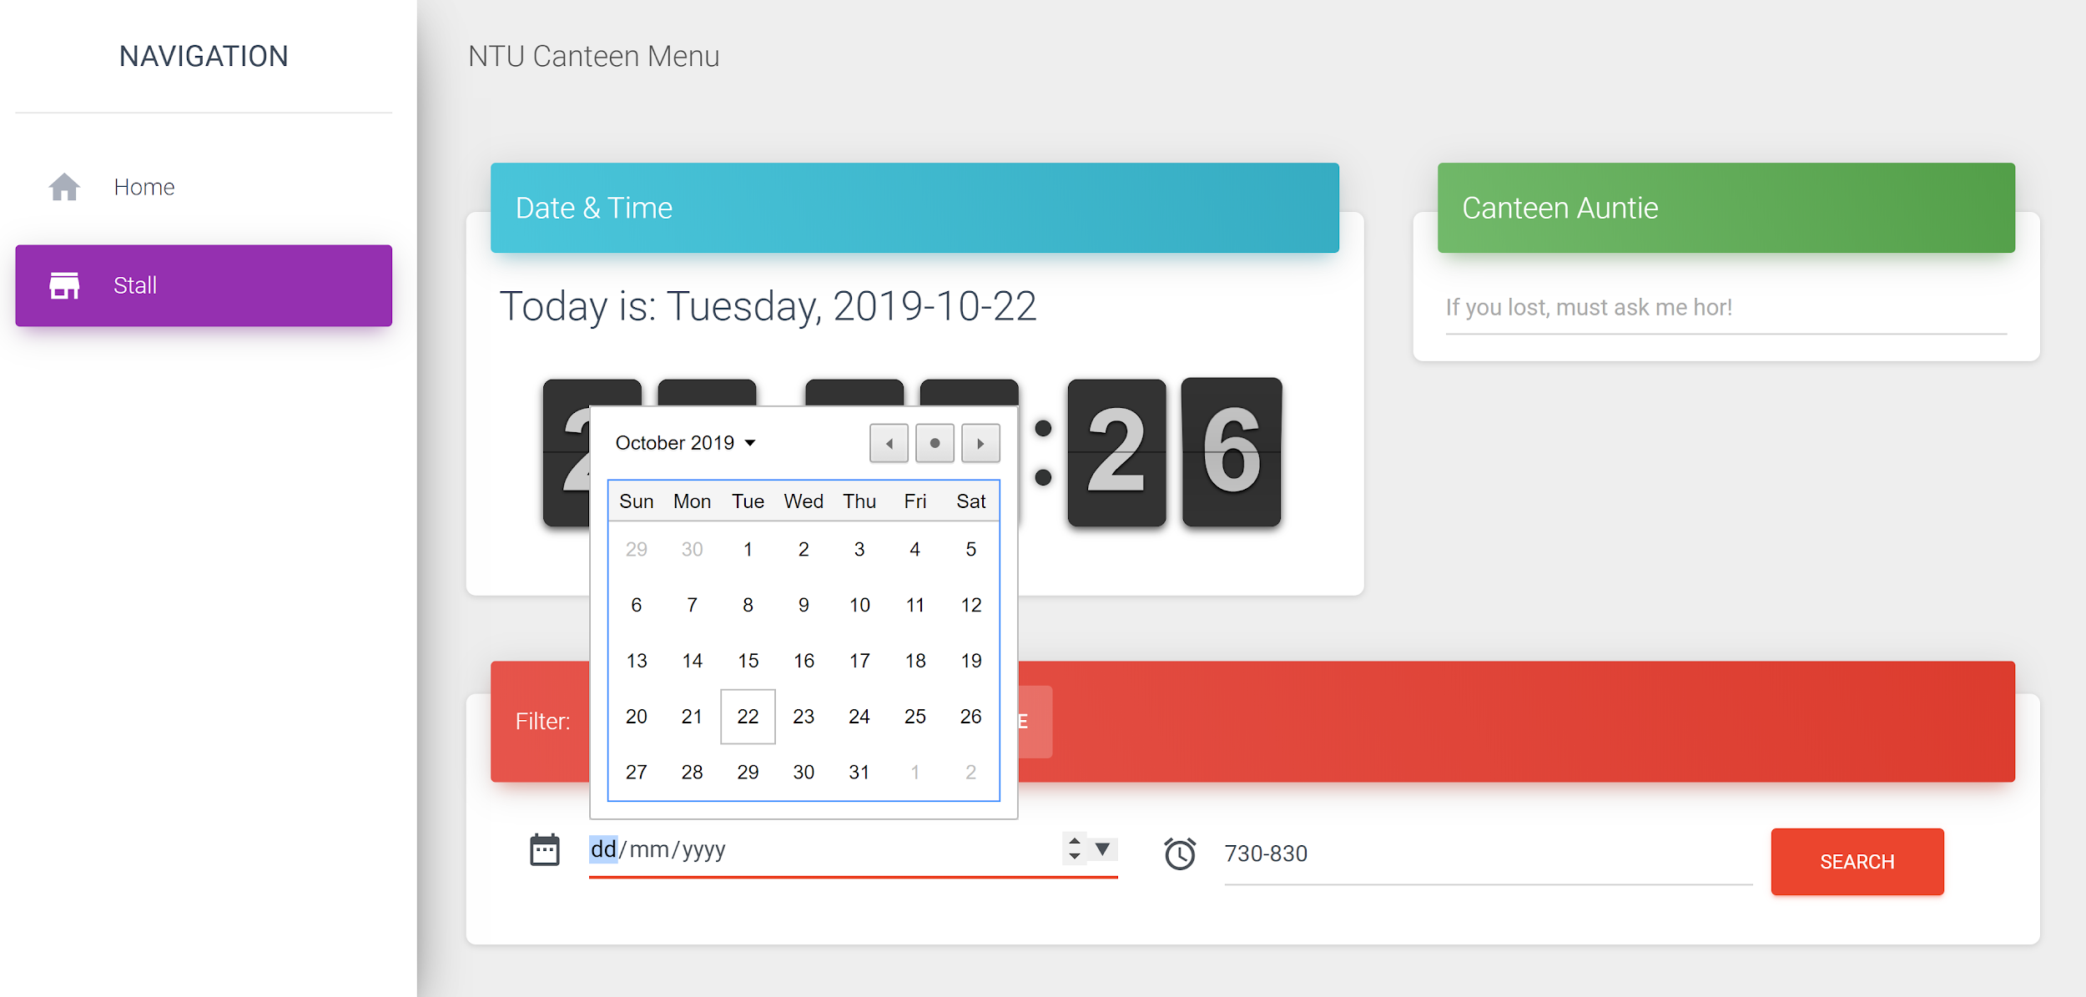

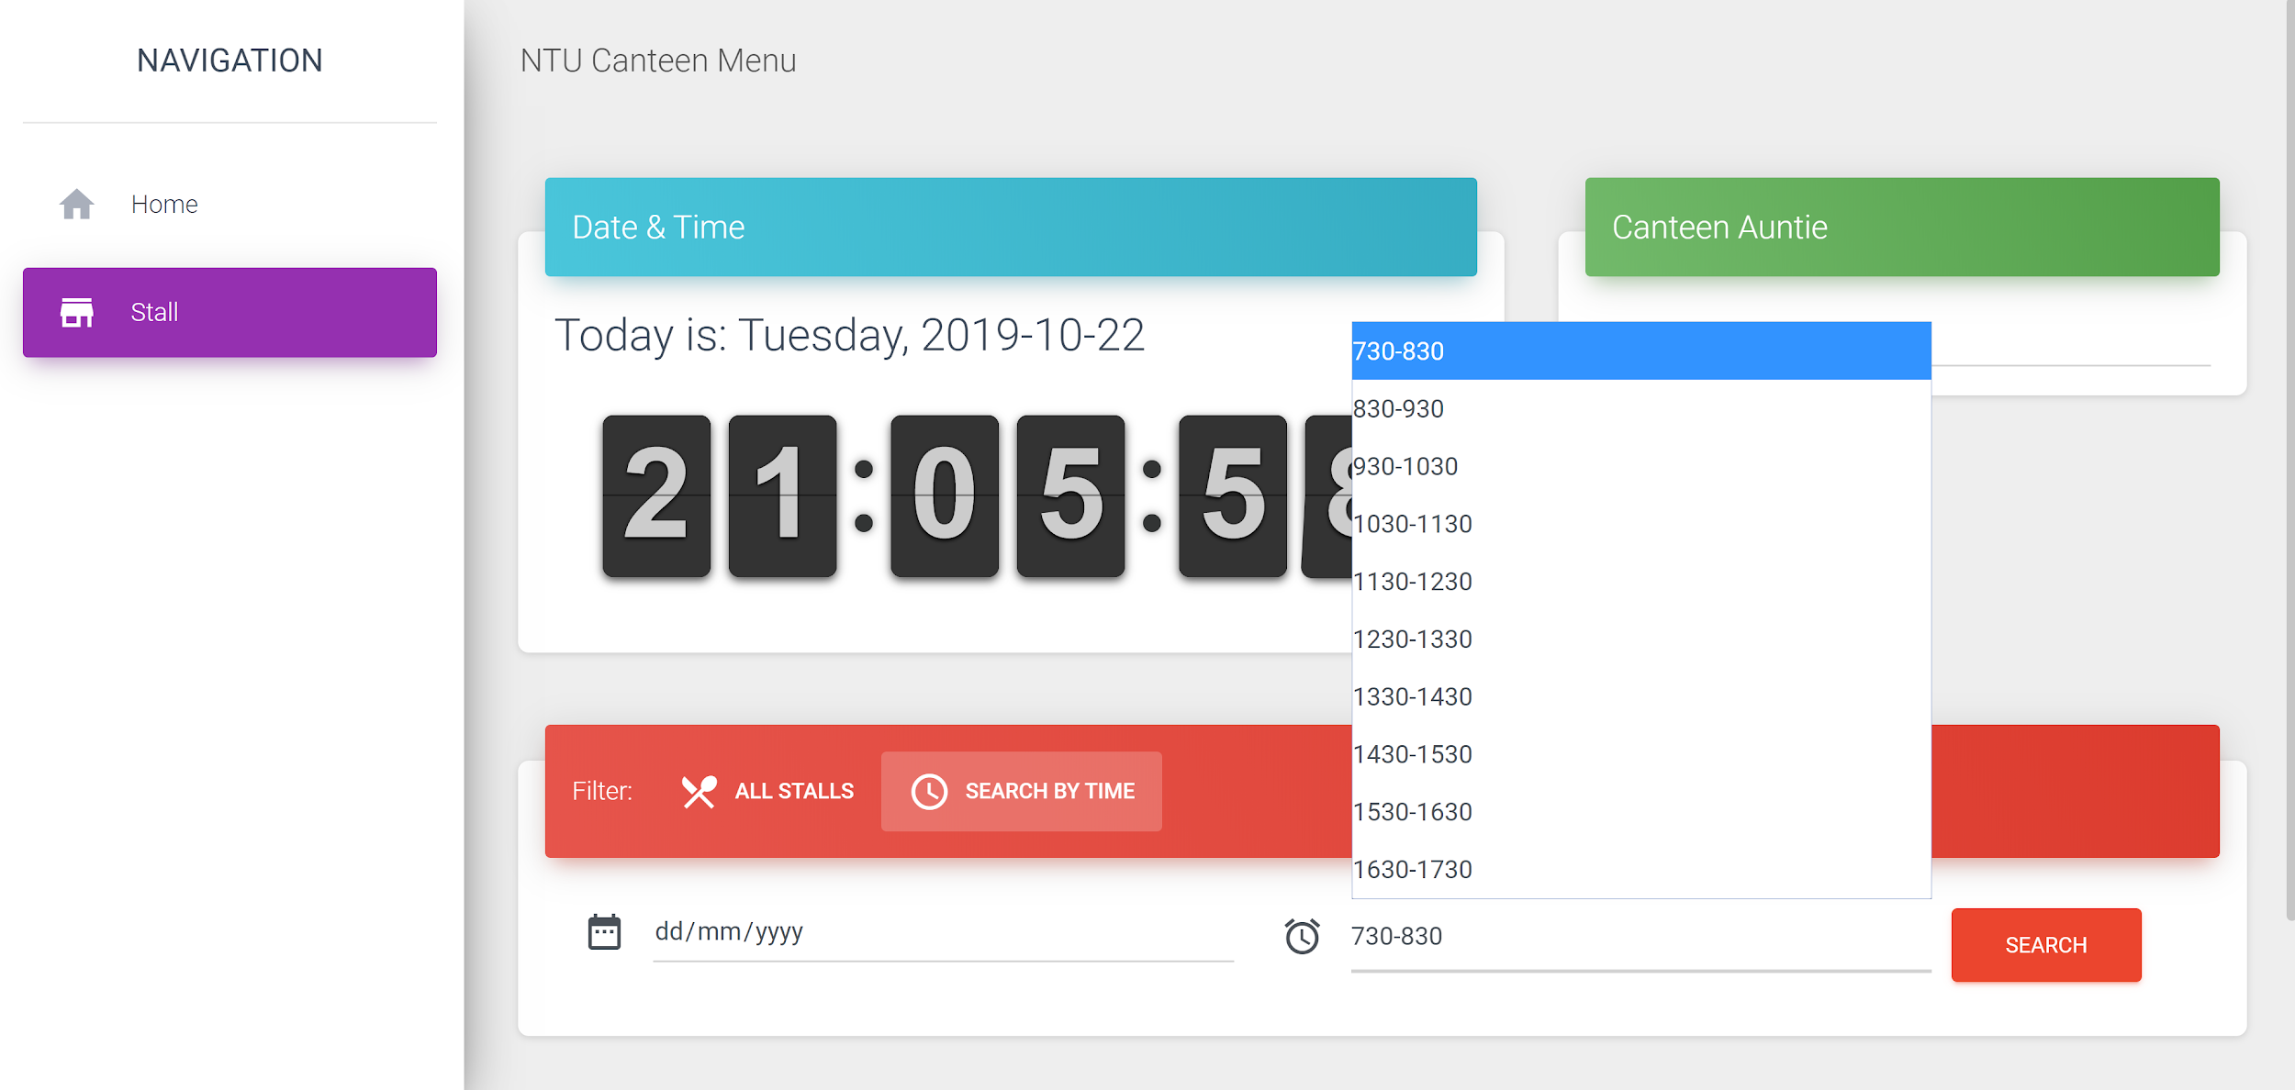

The form template is designed in SearchStallByDate.py which is imported into the main app.py file. With wtforms, we created a SearchStallByDate class with two inputs, for users to specify a date and time slot.

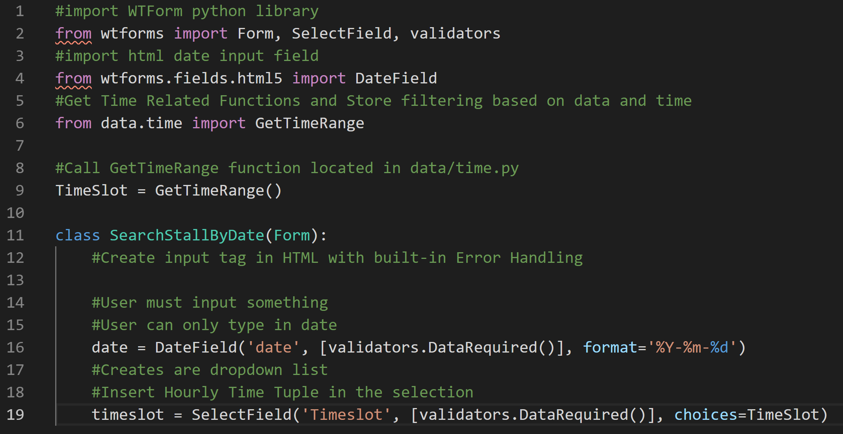

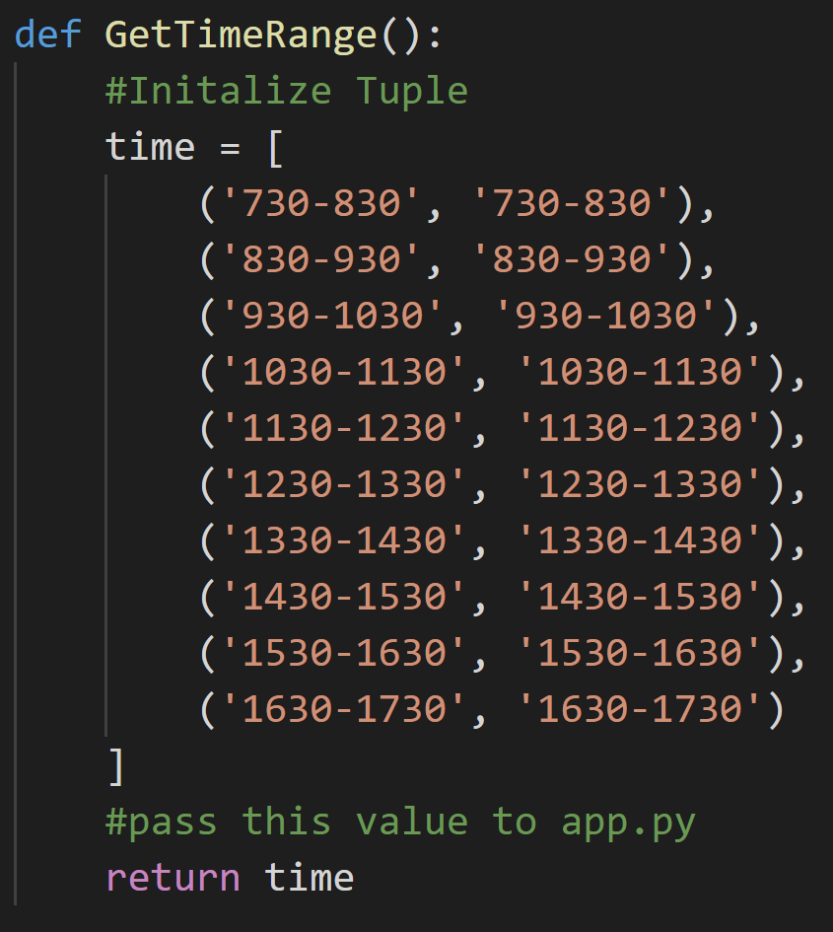

By submitting the form, a POST request is made to the server along with the user’s inputs. We capture the user’s **date** and **timeslot** input and run the QueryStallByTimeSlot function which we have imported from stall.py.

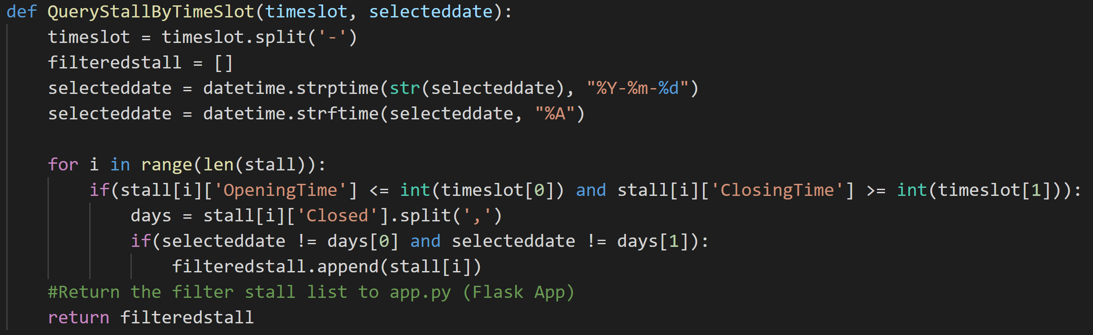

The QueryStallByTimeSlot function takes two arguments: user-defined timeslot and date. It creates a datetime object and converts it to a string of the given day eg “Monday”. A for loop is run through the list of stalls to check whether each stall is closed during the given time period. Stalls that are open are appended to an empty list **filteredstall**.

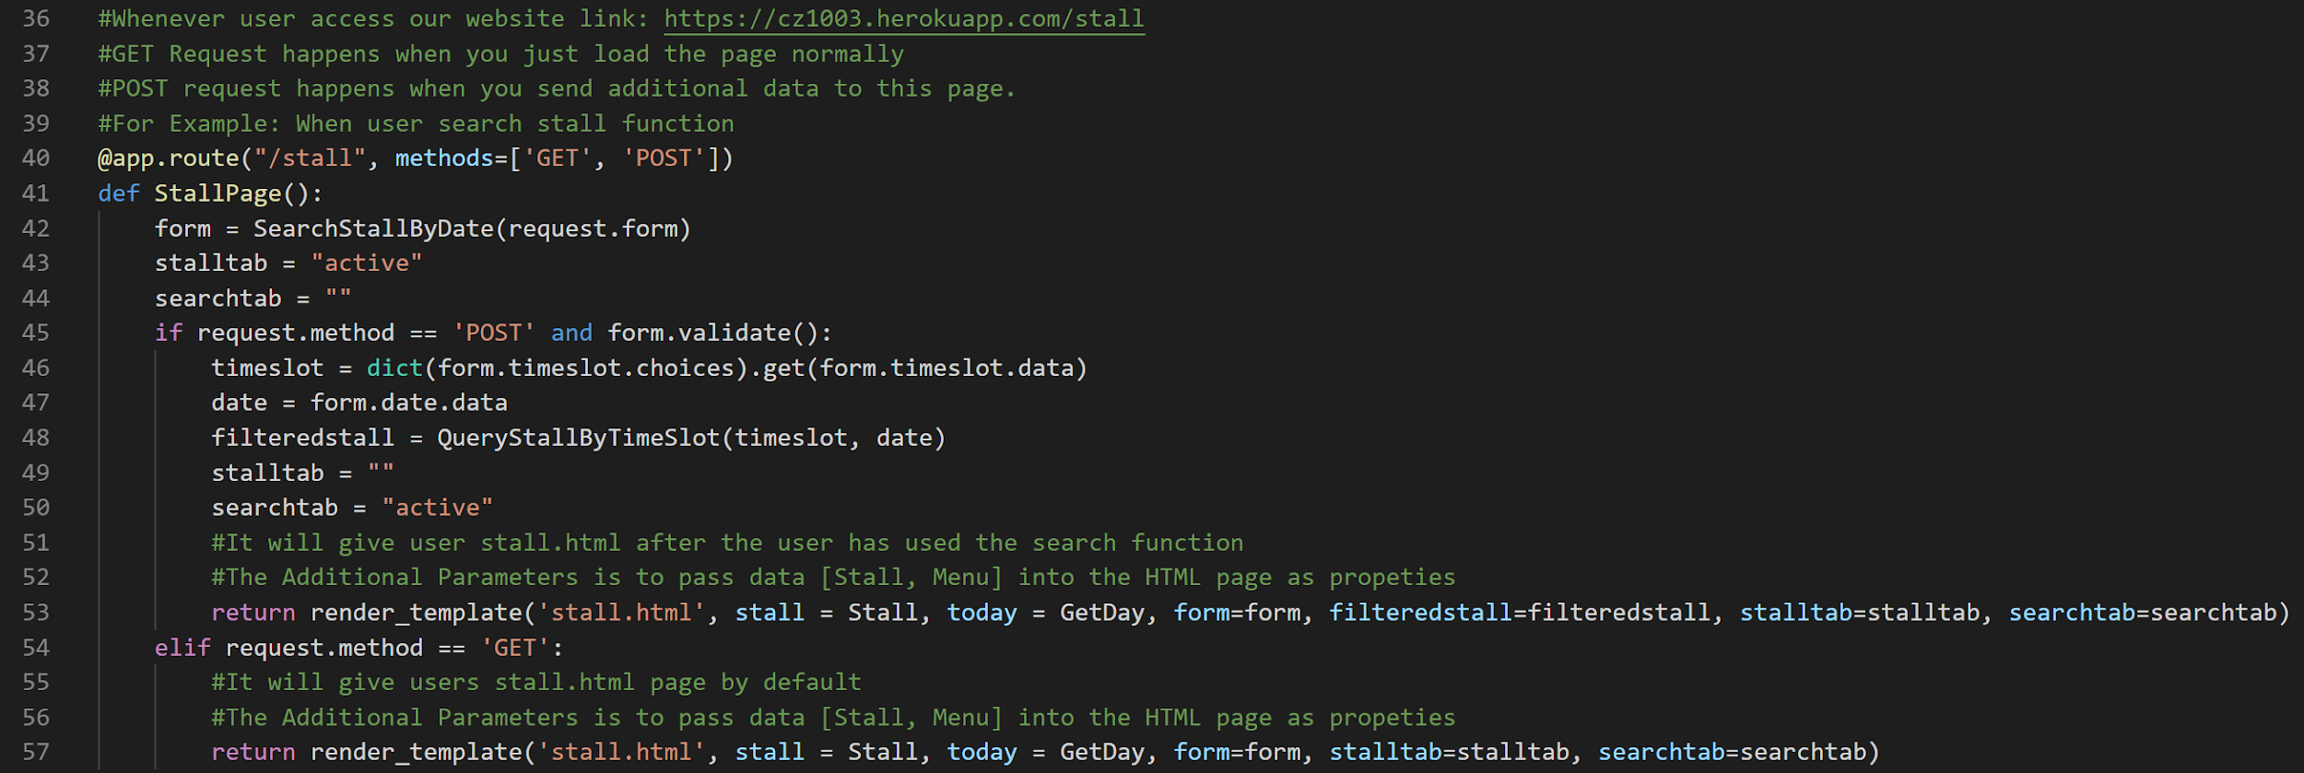

This filteredstall list containing all open stalls will be sent to the “/menu” page, thus displaying stall and menu information based on the user-defined date and time.

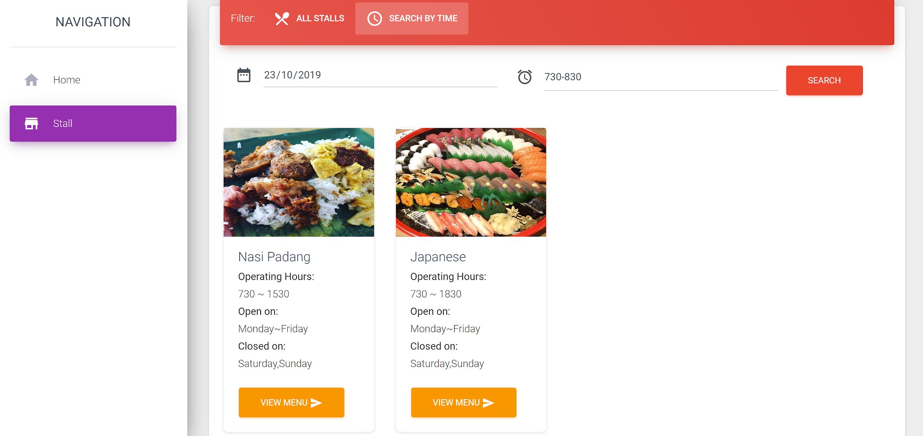

**E. Calculate estimated waiting time for the stall by asking user to enter the number of people in the queue**

After selecting “View Menu” for a particular stall, the user is brought to the stall’s menu page. Here, there is a form where the user can input the number of people in the queue to determine the estimated waiting time.

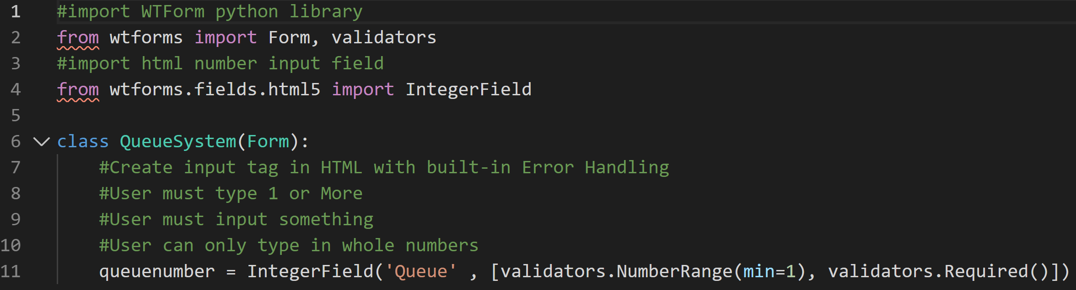

By utilizing wtforms with validation, we created a form that takes only an integer input from the user, greater than or equal to 1.

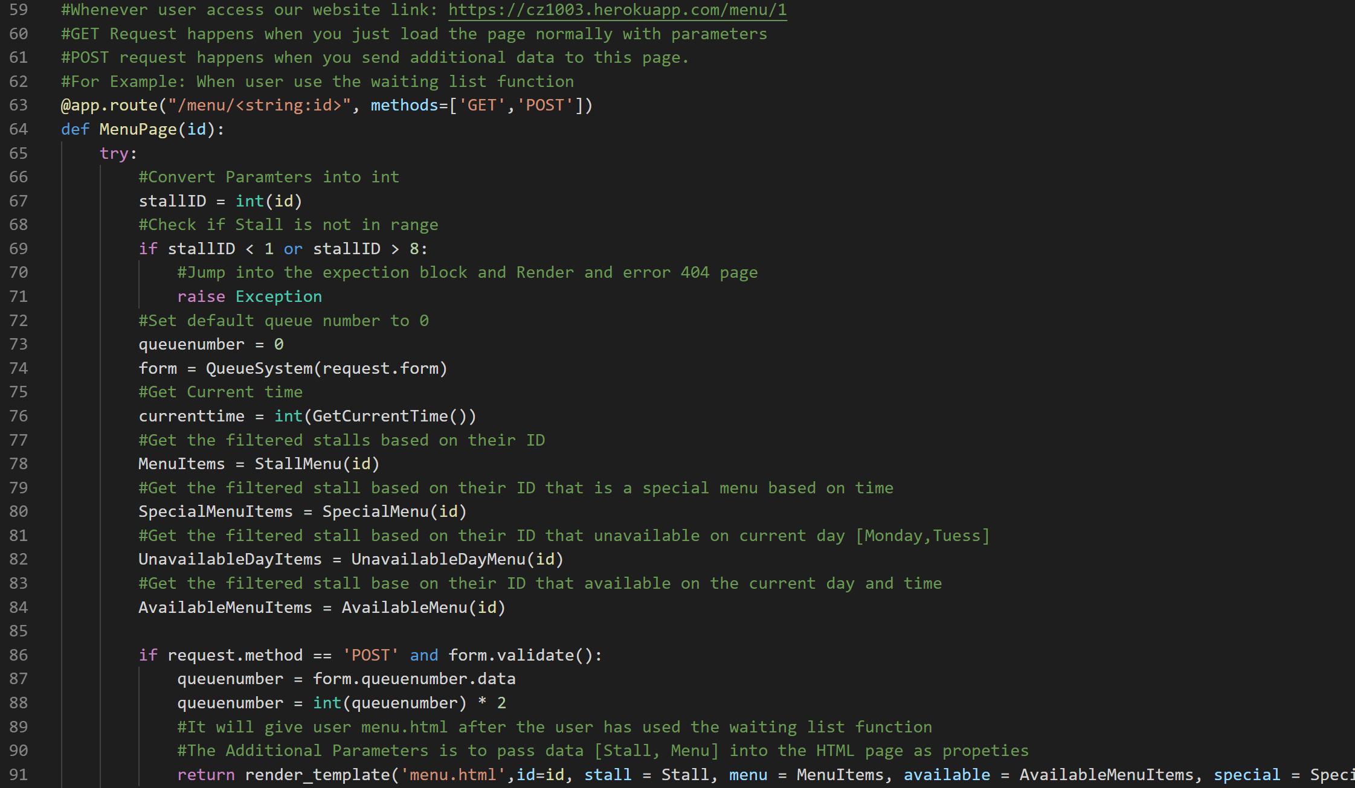

When the user submits an input to the form, a POST request is made and his input is received by the server. The user’s input is captured as **queuenumber**, which int() value is multiplied by 2 to obtain an estimate of the waiting time. This waiting time will then be sent and displayed when we pass this updated **queuenumber** to the “/menu” page.

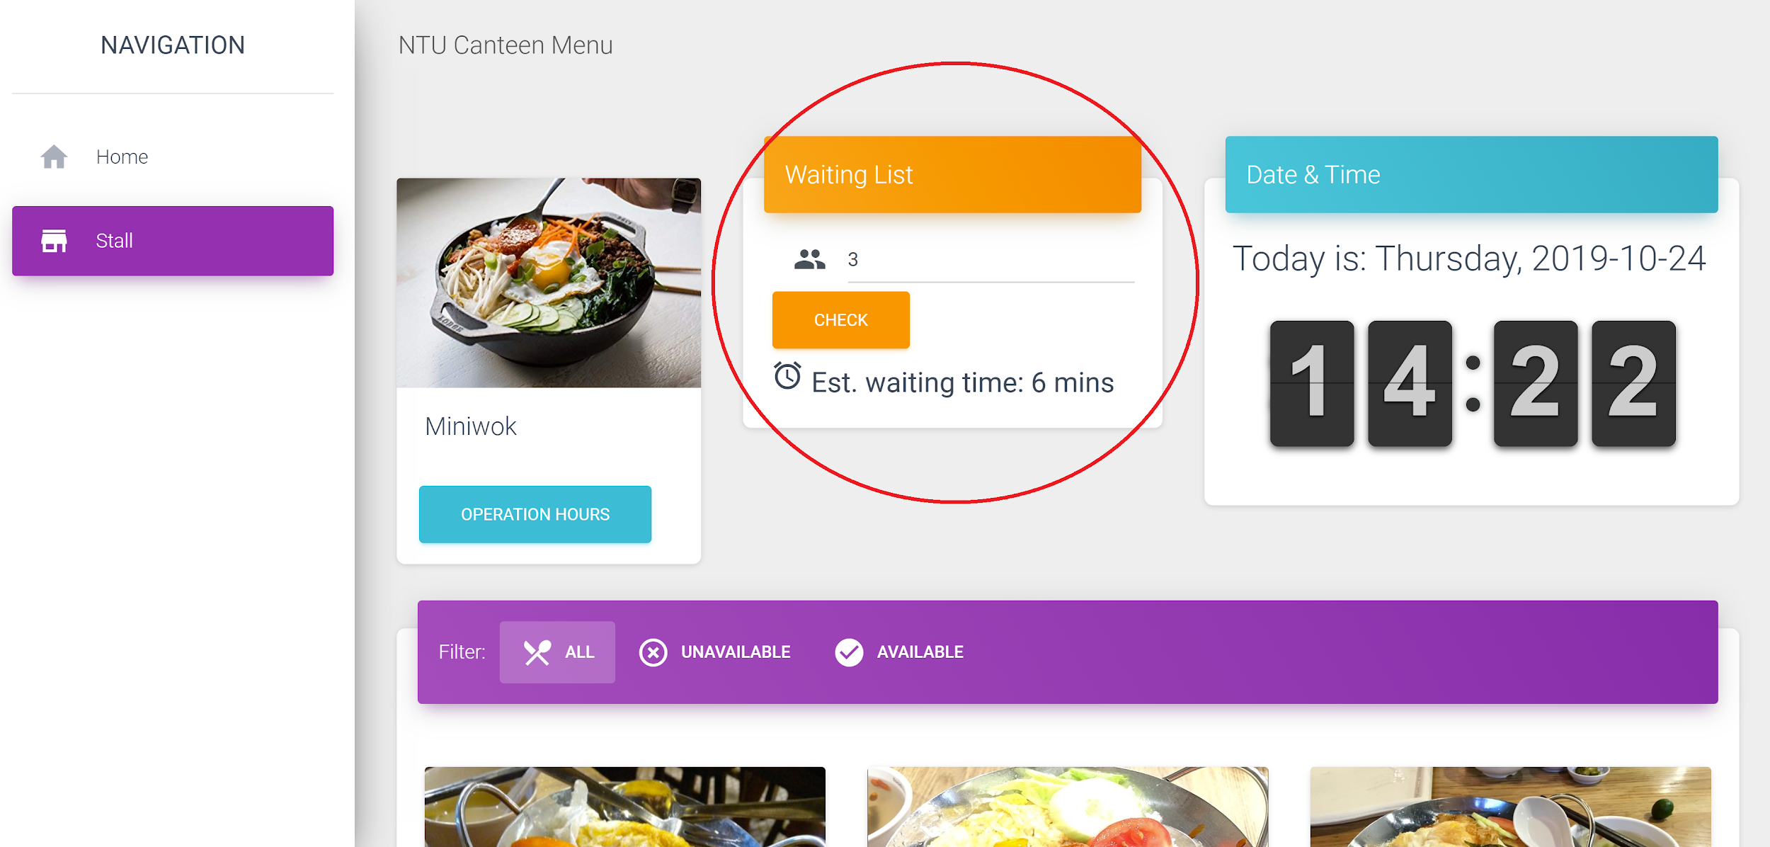

**F. Allow to check the operating hours for all stalls**

In the /menu page of a specific stall, users can check the operating hours of the stall by pressing on the “Operation Hours” button under the stall name. This will display the operating hours and days of the stall.

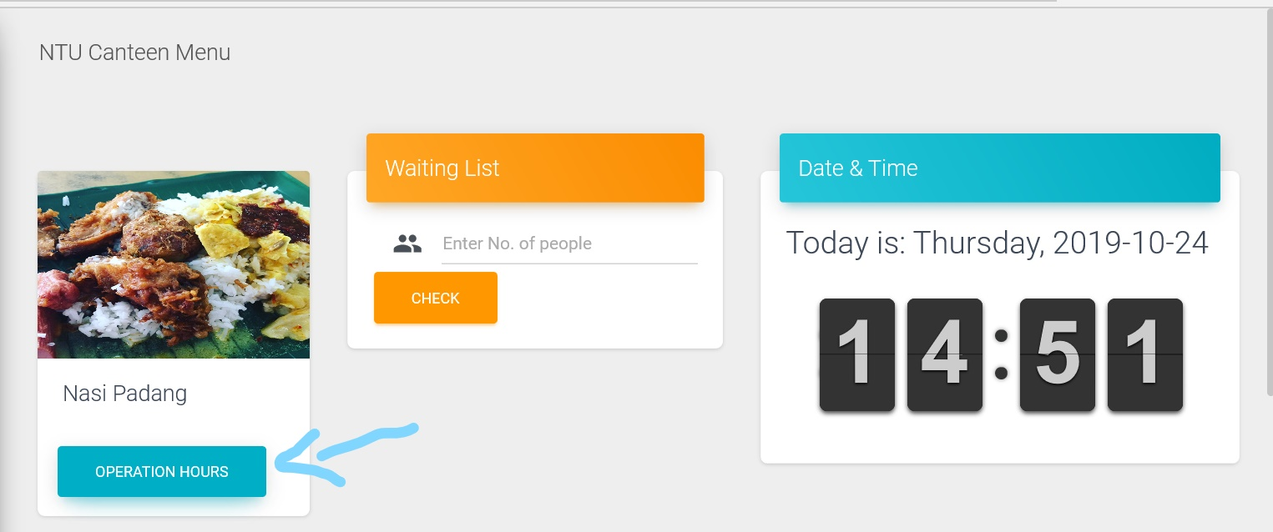

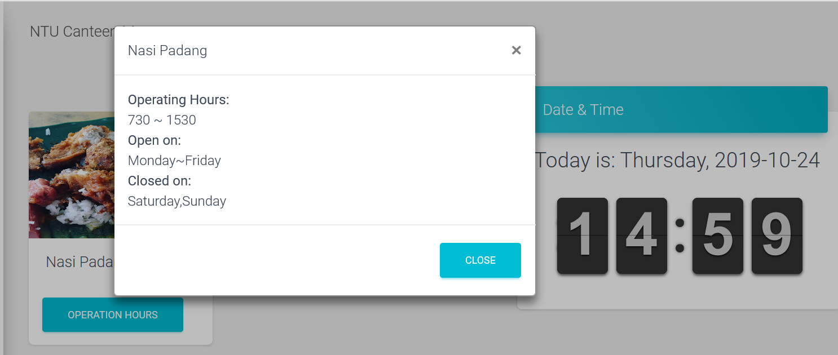

Information for the opening hours of each stall is stored in stall.json.

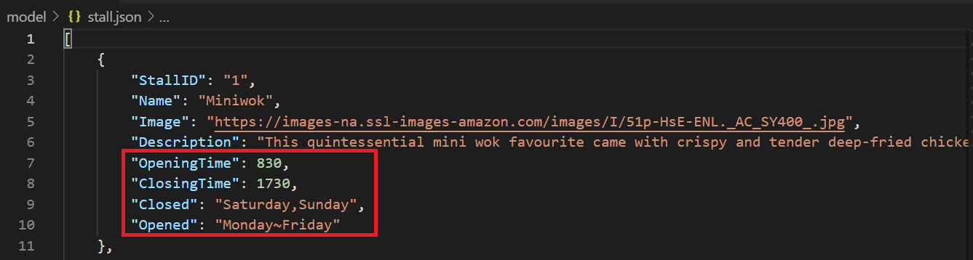

Stall information is passed to stall.py, which is then imported into the main app.py file, and called with Stall = GetAllStall(). The corresponding stall information is then passed into the html “menu” file. When the “Operation Hours” button is pressed, the system retrieves the data for the opening hours of the stall.

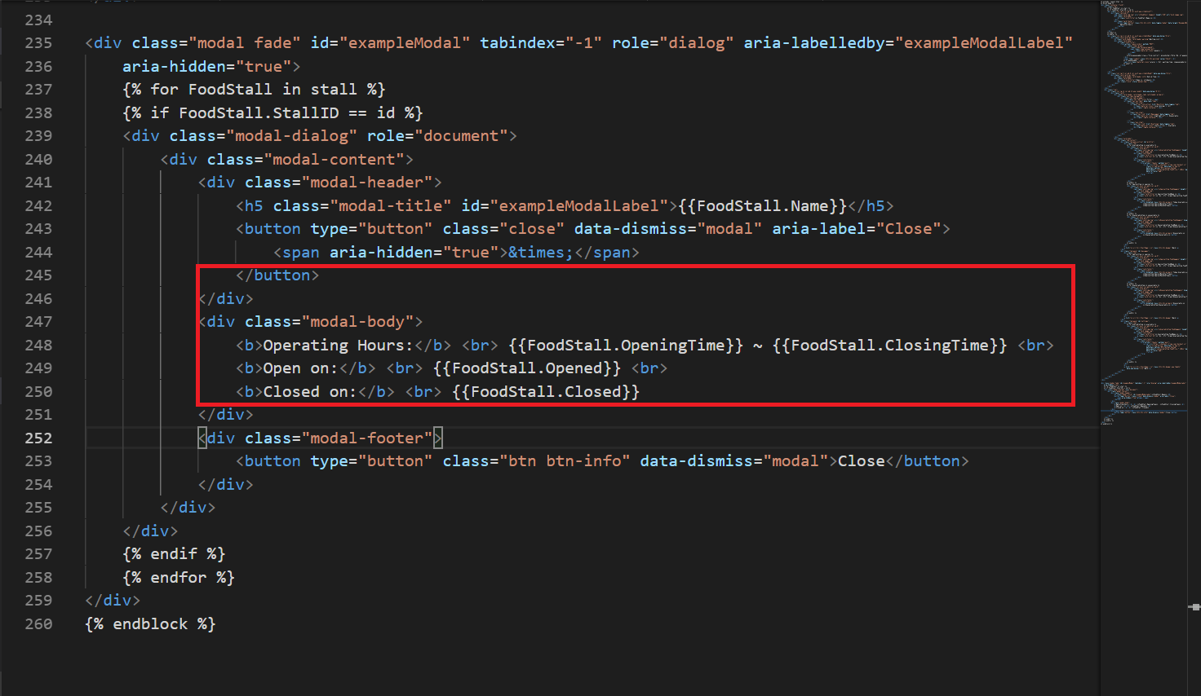

**Program Testing: Error Handling Test Cases**

1. Wrong user input in forms

User may enter wrong inputs for the SearchStallByDate and the Queue number form. Therefore, we use wtforms with validators set so that the forms will only allow a correct input from the user. Otherwise, it will continue to prompt for the correct input format.

1. Unspecified route

If the user tries to visit an unspecified route, they will be directed to an error page. After this, they will be redirected to the stalls page.

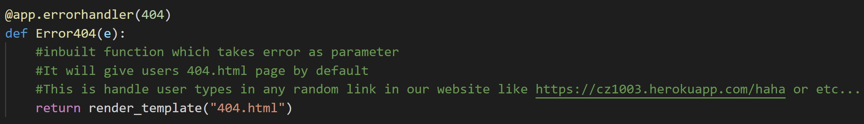

This also works when the user tries to manually visit a stall ID that does not exist, redirecting them to the error page using a try-except block.

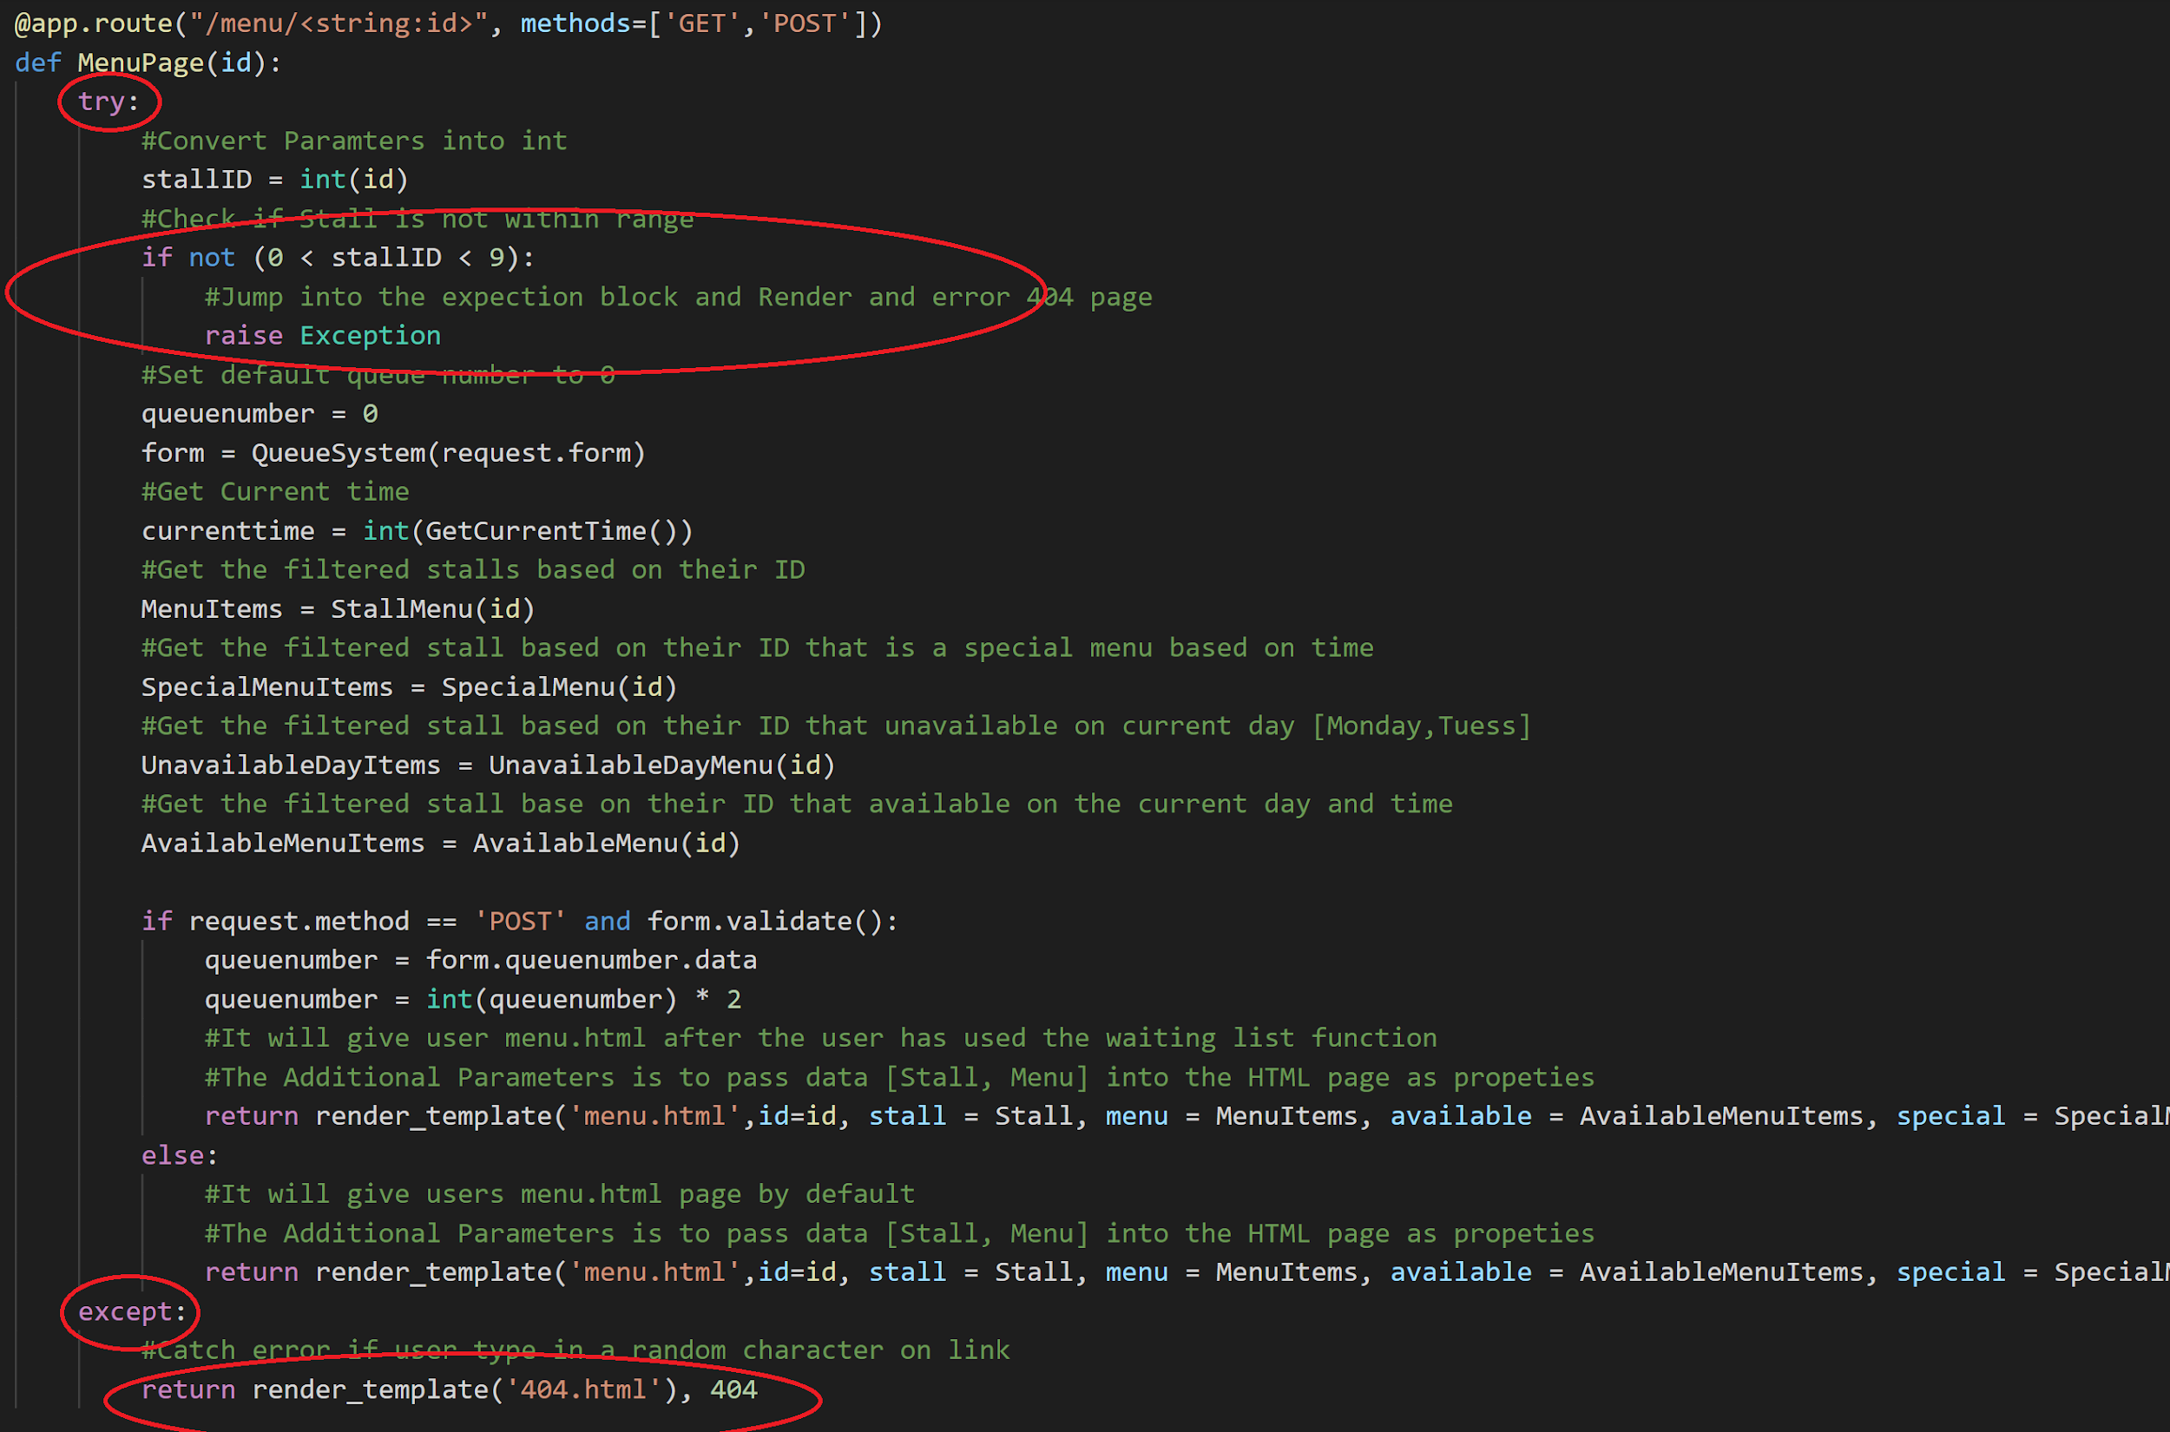

**Reflections**

Iskandar:   
Python Flask is micro web framework that could be use both as an API and Model View Controller (MVC) workflow. With the current project, I was able to use to object oriented program (OOP) concept to decouple the functions into smaller functions.   
  
Firstly, the hardest part for me was to learn the basic Python programming language from scratch. Secondly, I find the python syntax seems a little difficult for me to get familiarize even with prior working experiences with other programming languages. Thirdly, when I hosted my python project on a server, it keeps crashing because python project requires a lot of memory (2GB~) on Heroku cloud server in order to run the project. Lastly, teaching my teammates how to use Flask framework to write python codes directly on HTML.

Amadeus:

Firstly, I learnt how to utilise modules which are rather new to me. I found this difficult at first as it involves trying to understand someone’s code, which was quite advanced for a beginner myself. However, I find reading the documentation makes things much easier as I am able to understand the code’s functionality and will be able to use it even if I do not fully understand how that code is implemented (abstraction).

Next, I found it a good practice to segment code into its respective functionality. Code of different functionality should be separated into individual files. It is also good to encapsulate code into functions instead of hard-coding, making it reusable. This makes the code less cluttered and easy to use across multiple files without knowing how the actual function is implemented, allowing collaboration as well.

Benjamin:  
I learnt how to direct information from a python file using via the Flask framework and display the python values on a HTML web page using Object-Oriented Programming. By defining modules to return information eg. GetAllStall() returns stall information, I could import information to the main app.py file, so it could be displayed on a website.

The hardest part for me, as a beginner, was understanding code from others. For example, I had problems understanding the ‘GET’ and ‘POST’ methods in the main app.py file, and how it helped to transfer information and function.